ARP-SCAN TOOL – COMPREHENSIVE TECHNICAL DOCUMENTATION
A High-Speed ARP-Based Network Discovery Tool for Ethical Hacking & Penetration Testing
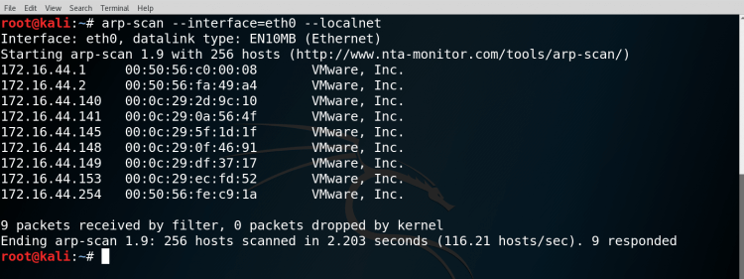
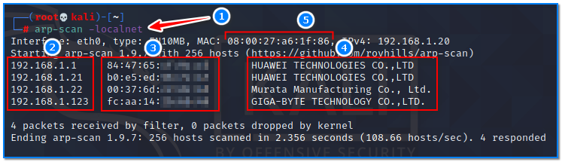
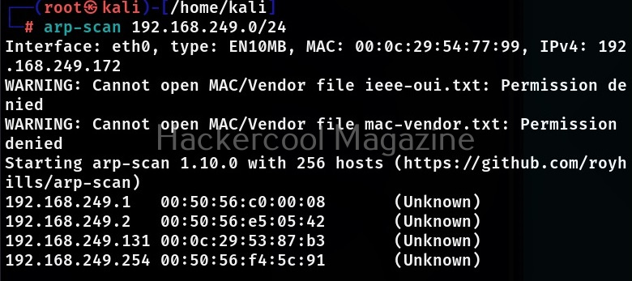
4

ABSTRACT
Internal network enumeration is a foundational step in penetration testing and security assessments. Identifying live hosts within a local area network enables testers to understand the network layout before performing deeper scans or exploitation. This document presents a comprehensive technical study of ARP-Scan, a fast and reliable ARP-based network discovery tool. The report explains the theoretical background of ARP scanning, the internal working mechanism of ARP-Scan, command usage, a practical case study, advantages, limitations, and defensive considerations. The objective of this documentation is to provide an academic and practical understanding of ARP-Scan suitable for cybersecurity coursework, lab records, and professional penetration testing engagements.

1. INTRODUCTION
In internal penetration testing scenarios, discovering all active devices connected to a network is critical. Many traditional discovery techniques rely on ICMP echo requests (ping), which are often blocked by firewalls or disabled on hosts. However, devices on a local network must respond to ARP (Address Resolution Protocol) requests to communicate with other systems.
ARP-Scan takes advantage of this requirement by broadcasting ARP requests across the network and recording responses from active hosts. This makes it one of the most accurate methods for discovering devices in a local subnet.

2. OBJECTIVE OF THE STUDY
The objectives of this documentation are:
- To understand ARP-based host discovery
- To study the working mechanism of ARP-Scan
- To analyze ARP-Scan command usage and options
- To demonstrate real-world usage through a practical case study
- To evaluate strengths, limitations, and security implications
- To provide exam-ready and submission-ready content

3. BACKGROUND: ARP SCANNING IN CYBER SECURITY
ARP is a protocol used to map IP addresses to MAC addresses within a local network. Since ARP operates at the link layer, it cannot be filtered easily without disrupting network communication.
ARP-based scanning allows testers to:
- Identify live hosts reliably
- Discover MAC addresses and vendors
- Detect hidden or firewalled devices
- Enumerate network gateways and switches
ARP-Scan specializes in high-speed ARP probing with accurate results.

4. OVERVIEW OF ARP-SCAN TOOL
ARP-Scan is an open-source network scanning tool designed to discover and fingerprint devices on a local network. It is commonly used in Kali Linux and other security-focused distributions.
Unlike interactive tools such as Netdiscover, ARP-Scan emphasizes speed, accuracy, and scripting support, making it ideal for automated internal reconnaissance.
ARP-Scan does not perform port scanning or exploitation. Its role is strictly limited to host discovery.

5. ARCHITECTURE AND WORKING MECHANISM
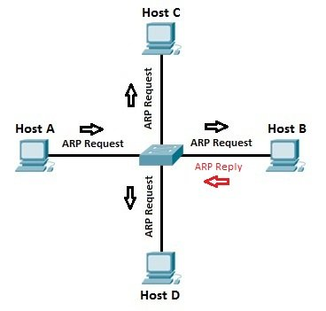

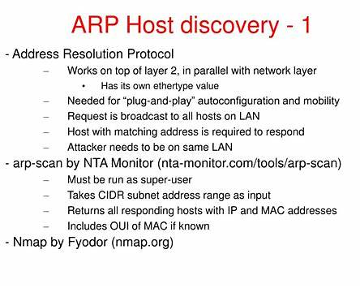
ARP-Scan operates through the following process:
- Interface Selection
The tool identifies the active network interface.
- ARP Packet Generation
ARP requests are broadcast to all IP addresses in the target range.
- Response Collection
Live hosts reply with their MAC addresses.
- Vendor Resolution
MAC addresses are mapped to vendor names.
- Result Output
Active hosts are displayed with IP, MAC, and vendor details.
This direct approach ensures reliable host discovery even in restricted networks.

6. INSTALLATION AND ENVIRONMENT
ARP-Scan is pre-installed in Kali Linux.
To verify installation:
arp-scan --help
ARP-Scan requires root privileges to send and receive raw ARP packets.

7. COMMAND USAGE AND ANALYSIS
7.1 Scan Local Network Automatically
arp-scan --localnet
Scans the local subnet based on interface configuration.

7.2 Scan a Specific Network Range
arp-scan 192.168.1.0/24
Performs ARP scanning on a defined subnet.

7.3 Specify Network Interface
arp-scan -i eth0 192.168.1.0/24
Used when multiple interfaces are present.

7.4 Disable Vendor Resolution
arp-scan --numeric --localnet
Outputs raw MAC addresses without vendor lookup.

7.5 Output to File
arp-scan --localnet > arp_scan_results.txt
Stores scan results for reporting or automation.

8. PRACTICAL CASE STUDY
Scenario
An internal security assessment is performed on a corporate LAN.
Execution
arp-scan --localnet
Observations
- Identified all active hosts on the subnet
- Discovered gateway and infrastructure devices
- Vendor details revealed servers, workstations, and virtual machines
Impact Analysis
ARP-Scan provided a complete and accurate list of active hosts, enabling efficient port scanning and vulnerability assessment in later phases.

9. ADVANTAGES OF ARP-SCAN
- Extremely fast host discovery
- High accuracy in local networks
- Works even when ICMP is blocked
- Ideal for automation and scripting
- Minimal configuration required

10. LIMITATIONS OF ARP-SCAN
- Limited to local networks
- Requires root privileges
- Generates noticeable ARP traffic
- No passive scanning mode

11. ARP-SCAN VS OTHER DISCOVERY TOOLS
Tool | Technique | Best Use Case
ARP-Scan | ARP scanning | Fast & accurate LAN discovery
Netdiscover | ARP scanning | Interactive internal recon
Nmap | Multi-protocol | Advanced scanning
Ping sweep | ICMP | Basic host discovery
ARP-Scan is best suited for high-speed internal enumeration.

12. SECURITY AND DEFENSIVE CONSIDERATIONS
Organizations can reduce ARP-based reconnaissance by:
- Implementing network segmentation
- Monitoring ARP traffic patterns
- Deploying intrusion detection systems
- Enforcing internal access controls

13. LEGAL AND ETHICAL CONSIDERATIONS
ARP-Scan must be used only on networks where explicit authorization has been granted. Unauthorized internal scanning can violate corporate policies and cyber laws.

14. CONCLUSION
ARP-Scan is a powerful and efficient network discovery tool that demonstrates how easily internal networks can be mapped using ARP-based techniques. Its speed and accuracy make it a preferred choice for internal penetration testing and security audits. Understanding ARP-Scan strengthens a cybersecurity student’s foundation in internal reconnaissance and network security assessment.

15. REFERENCES
- Kali Linux Official Documentation
- ARP Protocol – RFC 826
- OWASP Information Gathering Guide

